OBG STYLE GUIDE
Web Template (Advocate): http://themes.two2twelve.com/preview?theme=advocate
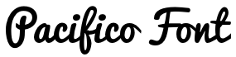
FONTS
Pacifico (Google)
Cabin (Google)
H1 - Pacifico 32px - color
H2 - Pacifico 24px - color
H3 - Cabin 24px (bold)
H4 - Cabin 20px (bold)
H5 - Cabin 15px
H6 - Cabin 13px - grey
COLORS
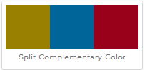
OBG Blue: 006699
R:0, G:102, B:153
http://www.colorhexa.com/006699
Red: 99001A
R:153, G:0, B:26
http://www.colorhexa.com/99001a
Green: 998000
R:153, G:128, B:0
http://www.colorhexa.com/998000
Purple: 660044
R:102, G:0, B:68
http://www.colorhexa.com/660044

ICONS
Font: FoundationIconsGeneral
Icon General
Icon General Enclosed
Icon Social
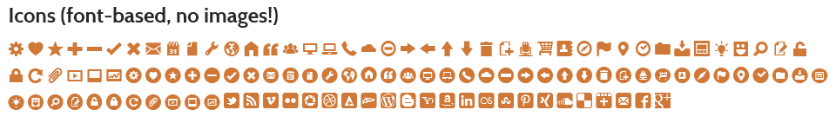

Slider - 620px × 285px
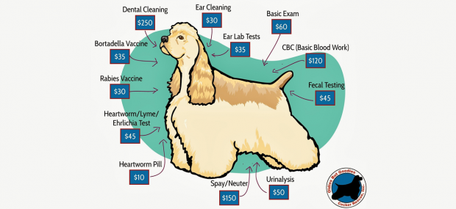
Page Header 700px x 244px
