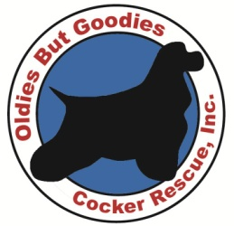
Oldies But Goodies Cocker Rescue
P.O. Box 361 • Newington, VA 22122-0361
www.cockerspanielrescue.com
703.533.2373 (voice mail)
info@cockerspanielrescue.com

February 11, 2014

Dear <<Merchant>>,

My name is <<Name>> and I am a volunteer with Oldies But Goodies Cocker Rescue. I am writing to ask for your support of Oldies But Goodies’ (OBG) <<Event Name>> to be held <<date>> at <<venue/location>> in <<city>>. We are asking for your help by donating << item or service>> to be used in our silent auction and would be truly grateful for anything you choose to offer.

This benefit will be open to the public and we will be recognizing our sponsors in our program materials. We hope this event will promote animal rescue in the DC metro area and foster a sense of community.

One hundred percent of the proceeds from this event will go directly to caring for the animals, many of whom are aging or in ill health. We pay for all the vetting on the dogs in our care. Some examples include spaying/neutering, all shots, surgeries on eyes, ears, orthopedic etc. Even better, we are based in the DC metro area so our funds are spent locally.

OBG is a 501(c)(3) organization (Tax ID: 54-1833707) and your donation is tax deductible (where applicable). If you have any questions, or need more information about this event, please feel free to contact me at <<phone>> or <<email>>. You can also learn more about OBG and our fundraising events on our website, www.cockerspanielrescue.com.

Thank you in advance for your time and support. Your consideration of my request is most appreciated, both by me and all the animals in our care!

Sincerely,

<<Name>>

<<Name>>
Volunteer, OBG Cocker Rescue

