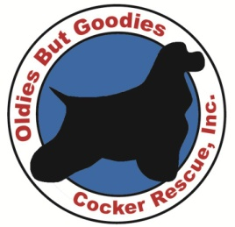
Oldies But Goodies Cocker Rescue
P.O. Box 361 • Newington, VA 22122-0361
www.cockerspanielrescue.com
703.533.2373 (voice mail)
info@cockerspanielrescue.com

Oldies But Goodies Cocker Rescue (OBG) is an all volunteer, non-profit 501(c)(3) organization based in the DC metro area. We are dedicated to rescuing, rehabilitating, and re-homing cocker spaniels and mixes. Our dogs have been given up, found as strays, or rescued from shelters throughout the mid-Atlantic region. We are true to our name and take in many “oldies but goodies;” often we are a senior dog’s last hope and these cases make for some of our happiest endings.

Since its inception in 1996, OBG has grown from a one-person rescue organization to become one of the largest breed-specific rescues in the United States, saving over 200 dogs in 2013. Currently, we are caring for over 75 homeless dogs of all ages in our foster homes.

Rescuing and rehabilitating needy dogs is a costly and often daunting task. In the past year, OBG paid over $300,000 locally to veterinarians, doggy daycare and other businesses -- funds that were obtained solely through donations, adoption fees, and fundraising events.

Just some of our Happy Tails…

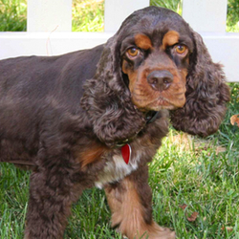
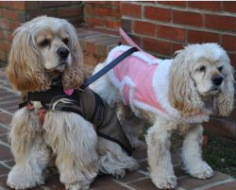
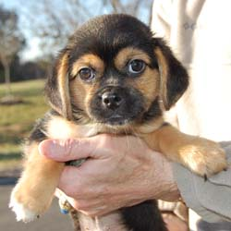
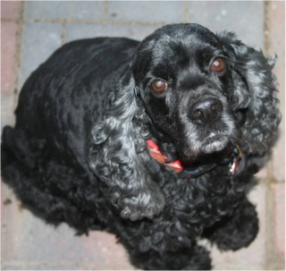
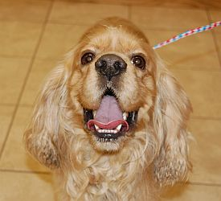
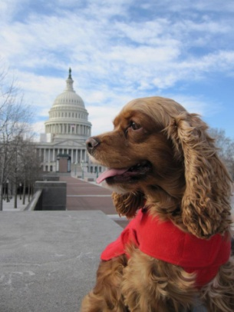
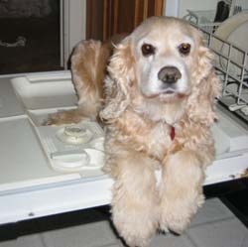
Thank you for your support as we celebrate
our 17th year of animal rescue!
Danny

Tea

Lucky Pup

Dasher

Tom

Joe Cocker & Betty Crocker

Zion

